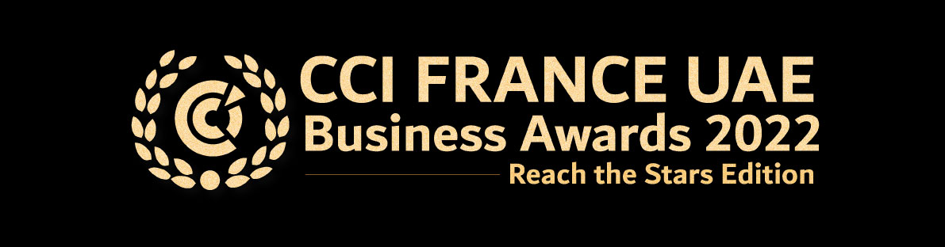

Application Form for: The Environmental, Social & Governance Award

First Name:

Last Name:

Company:

Tel:

Email:

I, the undersigned, apply for the CCI FRANCE UAE BUSINESS AWARD 2022 – The Environmental, Social & Governance Award.

Signature: Date:

In order for your application to be completed, these documents have to be submitted before Friday, February 18th, 2022, to Caroline Sabbagh - Events Executive - Gala@fbcdubai.com

- This application form signed
- Your application filled on the official online form

